Santa Cruz - Capitola Skiff Rental Experience
Skiff rental at Santa Cruz and Capitola is as fun and exciting as you can possibly dream up. No trip is ever the same; everyone being memorable in its own right. You might see schools of dolphin, breaching whales, sharks, sunfish, many varieties of jelly fish, schools of bait fish boiling as salmon or striper surround the “bait ball”, you name it, it can happen! How much more “one on one” with nature can you get than taking a small boat out on the ocean and fishing with your family or friends? You can’t, as there is nothing that compares to it.
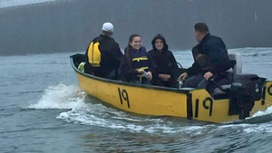

My First Experience....
I had never considered a skiff as it intimidated me and seemed a bit scary until I got invited with my son by two strangers who I jokingly asked “Do you have room for us?” while we were buying bait for fishing off the pier one day. They invited us and from that day we were hooked!!! No more doubt or fear. I decided to write this article up to help others walk through the experience mentally. Through my personal experience I want to help others get to understand the whole process and get prepared and comfortable with the idea to live this experience in person. If you don’t want to commit to a whole day, you can rent it by the hour and it’s really fun to just "motor" around the calm waters of the pier, just leave clearance for those fishing lines. Get your feet wet and do something that will give you the appreciation of what world class fishery we have right here in our backyard and the breathtaking opportunities and activities available to us. You will become a new person after this experience!

First Time Preparation.....
Visit this link to get a run through on how to operate the gas motor on the skiff before going. It’s so easy you do not have to any experience to grasp the easy process.
http://capitolaboatandbait.com/rentals/motorized-skiffs/skiff-rental-university
About the Businesses.....
The Santa Cruz & Capitola boat rental and shops are run by a friendly group of people who have been doing this for decades and own both locations, but are run individually through their respective shops. Each location has a boundary that they let you know as to how far you can travel within to ensure you return in time. It’s a really big boundary FYI. Both locations have a tackle and gift shop loaded with everything you need for fishing and more including bait. You can literally have nothing with you and buy everything for ocean fishing right there and at a great price ESPECIALLY with our club member discounts for both boat rental AND the shop! If you visit them, thank the manager or owner for this discount. They don’t just rent skiffs (fishing boats) Paddle Boards & Kayaks too!
The Santa Cruz location doesn’t have a website of their own, but they do have a Facebook page. I suggest visiting both as you can see pictures and get info on the businesses.
WEBSITE for BOTH Capitola and Santa Cruz: http://capitolaboatandbait.com/
SANTA CRUZ BOAT RENTAL AND TACKLE SHOP
https://www.instagram.com/santacruzboatrentals/
https://www.facebook.com/SantaCruzBoatRental

CAPITOLA BOAT RENTAL AND TACKLE SHOP
https://www.instagram.com/capitolaboatandbait/
https://www.facebook.com/CapitolaBoatandBait
Rental Info...
Mon-Fri - 1st come-first serve for rentals. Boats will not be let out until sunrise for safety. Always call a few days in advance to verify the process, when the shop itself opens up for registration and deposit, weather forecast the day before you plan to go out, pricing, reservation requirements for weekends and holidays, parking specifics, gear rental availability and info if needed, ect.
WEEKENDS / HOLIDAYS - Because of high demand, reservations are required in advance with a credit hold that can be cancelled up to one day before. Time Slots are issued for reservations, so the earlier you book the better. It's best to get there early. You need to fill out a form for the rental. 4 people max per boat with a $175/day or hourly rate of $50/hour.
My personal suggestion is no more than 3 large adults OR 2 adults and 2 kiddos is max for comfortable for all the gear included.

Parking Info....
SANTA CRUZ – You can park right on the pier directly in front of the boat rental where you can unload and load up after fishing, just feet away from your car. It’s a major convenience not to have to walk far carrying a bunch of gear, fish bag, ect. the entrance gate will likely be up when you arrive if early. Before you leave you get a major discounted ticket from the boat rental which ends up around $8-14 for the whole day depending if you stay longer (fish cleaning, restaurants, etc.) We do both and have paid $8. If you don’t get the ticket from the boat guy, it will be around $25-30 for the day, so DON’T FORGET TO SK FOR THE PARKING VOUCHER IT”S FREE!
CAPITOLA – It is a bit more difficult since you can’t park on the pier itself and parking around the smaller town can be tough especially the later in the day it gets. You have to drop your stuff off at the entrance of the pier and have someone stay with it while you go park. There is little free parking and you have to drive to the top of the hill to find it. Best to call the shop to get more info.
Before You Go Out....
Similar to a charter boat, you are going out on the unpredictable ocean. The skiff is a 14 or 16’ boat compared to a 53 ft charter boat, so the motion will impact you if you don’t take motion sickness prevention. You NEED to take BONINE or DRAMAMINE the night before (1 at 9pm is my routine) and one when you wake up right away. Even better if you can get your doctor to prescribe Scopolamine, it is a patch that has few to no effects and is what I take now every time I go fishing as well as my son. If you fail to follow this suggestion, you will experience the ultimate in sickness (most people). If you take it only in the AM, it has the opposite effect and you can possibly get even sicker as your body doesn’t have time to acclimate to the medication. Understand that these pills will make you drowsy; no question. It’s a tradeoff of having a great day of fishing and not getting sick and getting horribly sick! You can always try a couple hours of rental and see how it goes or fish closer to shore where the water is calmer than farther out from the pier. The shop may even allow you to try an hour paid and if good extend for the day.
Where to Fish....
Download Google Maps on your phone. Bring your cell phone and have a charging bank available with you. Use Google Sattelite View and you will see a live visual representation of where you are in the ocean. The map reveals exactly where the rock structure is and it’s dead accurate. Structure/shaded area on the map is where the fish are! I have recently found the edge of structure and flat bottom seems to be most productive because, I believe, the fish can hide in the rocks or right off the edge and surprise the bait when it passes in the wide open. You can also mark and label spots on the phone app/map and save them for future reference. No fish finder needed! Many times I end up fishing right next to a charter boat with 35 people on it who paid $120/person to fish the same spot where I am with a couple friends for less then ½ the cost and I control where I go with no worries about tangling lines with 30 other people.
Santa Cruz OR Capitola Boat Rental? What is the difference?
Capitola is know to be a calmer more protected area when fishing closer to shore line. Halibut are more commonly caught in Capitola compared to SC because halibut generally like calmer water and flat sandy bottom. Santa Cruz has a lot more structure (rocky bottom) which is the habitat rock cod and ling cod like to live in and around. I have typically fished SC, so I cannot say from personal experience how Capitola compares fishing wise. I recommend calling and talking to both shops to see what the latest action/catch has been like. I love the convenience of the pier parking, the restaurants right there, ect at SC, so for me it’s hard to go try Capitola for my first time.

Special Information....
There are times where a toxic algae develops in the ocean and this is called RED TIDE. I ALWAYS call a week and then days before going to gather details. I make sure there isn’t any RED TIDE that can last for days or weeks at a time, because it kills the fish bite. Pointless to go out during these times. I also find out about the weather and water conditions. We have another article about how to research and understand how to PLAN for a trip, so safety risk is reduces, which maximizes your fishing experience and success.
What You Need to Know....
There are regulations for wht type of fish can be kept, some species or varieties have size limits and even how many of each variety you can keep from zero to 10 for one species for example. Rock cod, ling cod, and halibut are your common fish species that are caught off the skiffs. You can catch also Cabazon, sharks, se trout, eel, white sea bass (the ghost of the ocean), octopus, lots of bait fish like anchovy, herring, king fish and squid (Calamari). You can find the regulations at the website for California Dpt of Fish and Wildlife (CDFW). Every year new regulations are posted, so make sure you reviewing the current regs. Two critical LINKS HERE:
https://wildlife.ca.gov/Fishing/Ocean/Regulations/Fishing-Map/San-Francisco
https://wildlife.ca.gov/Fishing/Ocean/Regulations/Sport-Fishing
What to Expect....
Almost every morning the water is calm. Around 11am, wind picks up and typically, so do the waves. It’s best to be heading south (back in) at the end of the day so the waves are pushing you in (tail wind and current), instead of coming at you (head wind) which will be a very wet, choppy and uncomfortable and slow ride back if conditions get rough. The ideal conditions are an overcast day with waves in the 3-5 max or less foot range and 10-15 seconds between waves. The more time between waves, the better. Bigger than 6 foot swell and less than a 10 second period between swells is a rough condition. There is also wind. Wind can increase the intensity of both swell (or waves) and impact of time period between swells. Wind is preferable to be less than 10 MPH at all times, Over is not good. A completely dead wind is also not the most preferred thing for fishing as a little wind (2-6 MPH) moves the boat across the surface allowing you to cover large area and find fish. If your not “Drifting” (moving across the water) then your not as likely to catch the fish as they are spread out and looking for food.
Start early in the day because the weather is best during the first half of the day. Come close to shore during the second half of the day where the water is protected and calmer. There is a point about a mile out where the wind and waves become more prevalent in the late afternoon. You can fish for Halibut and Stripers closer in. The bite is best during the earlier hours, although I have experienced many days where the bite was good all day. Boats must be back by 3PM. At the furthest distance, it can take 45 minutes to 1.5 hours to return so don’t start heading back later than 2PM if you are way out there (max 3-6 miles). There is a lot of structure and rock to fish close by, so we start far out and work our way in so we can maximize our fishing time (lines in water) and most importantly not be heading into waves that get you wet and slow you down when you start fishing close by then decide to head out.

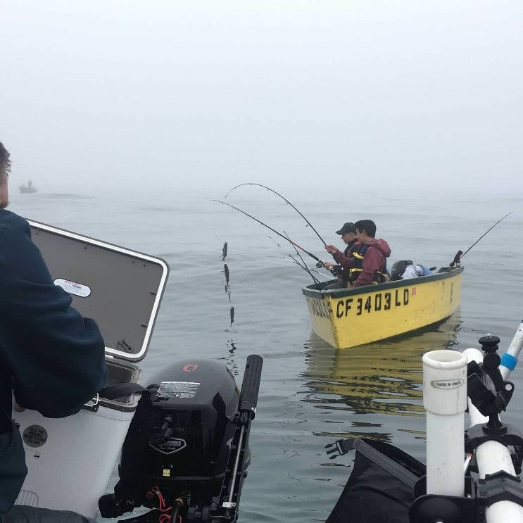
General Gear, Tackle & Preparation For a Fishing Trip....
· Clothing: pullover sweater with hood, waterproof shell, waterproof boots.
· Standard Items: Sun block, sun glasses, water bottle, snacks, etc.
· Bag to hold/carry fish: Stringer can work over the side; just pull up over before taking off or if a Seal or Shark is sighted!

· Tackle bag or box: Flies, swim baits, weights, all that you’d take on a party boat.
· Fishing License: (In case the DFG checks you!) - BUY BEFORE YOU GO!!!
· SIBIKI rigs: specific for catching live bait. Sold in shop but a little more $. Learn more in other tutorials!
· Bait Tank: About a gallon size, cheap at any fish supply store (Fishery Supply, Fisherman’s. There is one you can hang over the side of the boat and allows the water to move in and out keeping the bait fish alive. Live bait is the key to catching fish!!!!
· Salt water worthy pliers/cutters: For removing hooks and cutting line.
· Bait: Frozen squid, anchovy, etc. Also Procure Scent (Sardine, Herring, Shrimp); my favorite!
· Magnetic Compass: In case the fog rolls in and it rolls in suddenly out of nowhere, the cell phone dies, and you cannot see shore. This is a frightening experience, so be prepared. Typical when you have a marine layer or on an overcast day. Typically when it’s sunny you can see shore from 10 miles out no problem. Always be prepared. Sometimes that nice cool marine layer sticks around all day.
· Knife: I bring a bait cut knife and also a fillet knife as there are cleaning tables at the pier! No need to take your fish home and deal with that mess if you prefer not to use the whole fish. You also might catch a shark and want to clean that right away. Sharks don’t have bladders so critical to clean immediately.
· Plastic LARGE zip-lock bags: To place and transport fish if you choose to fillet your fish on the dock. The boat rental company provides a gaff, nice net, oars, life vests, and cutting board.

Ocean Fishing Tackle....
· Light to medium weight rod and reel for salt water with minimum of 40 lb test mono or braid. I carry a trout rod for my sibiki/live bait set up and my strong ocean rod for catching the big fish. Having these two rods saves a lot of time wasted from having to change leaders and set ups. Time in the water is time you can catch a fish! A line out of water means you missed that fish you passed over.
· Weights from 2 oz (casting into kelp) to 16 or even 20 oz for deep water up to 200 feet at boundaries. Sibiki set up 4-10 oz. Main rod 8-20 oz.
· Common tackle to carry: preferred tackle, leader, swivel clips, hooks, leader line (25lb test) for example.
· Sibiki leaders: From 12 (smallest) to 4. Main rod 3/0 to 9/0 as your preference. Used to catch live bait fish. Read our tutorials on how to do this in depth.
· Leader Line: If your leader breaks off and or gets damaged from fish teeth, you need another leader! Read our tutorial on how to make your own leaders and the different styles! You can also buy pre-made leaders, but custom leaders seem to do better.
· Trash Bags: You will appreciate having multiple trash bags from bait packaging, food packaging, empty drink bottles, broken and or used tackle with hooks, ect. Best to keep tackle that has seen saltwater separate from your unused clean tackle. The salt will transfer to other items and cause them to rust.
· Waterproof Bag: For keeping things DRY. Food, clothes removed, Electronics, etc. It will get wet with waves splshing, fish flying all around, pulling in strung up fish or bait bucket. Electronics get destroyed from salt water and need to be double or triple protected in waterproof container. You will thank me for this. I even put electronics in a couple zip locks inside a water proof bag. Water will get where you least expect always!!!

Suggested Process Summarized....
1. Arrive at 5:30am, or earlier, to get in line for opening at 6am.
2. Fill the rental form out. All adults need to sign the form. Buy your supplies at the same time if needed including frozen bait they sell. (Club members get DISCOUNT on boat rental AND anything bought in SHOP!)
3. Unload your car and load the boat # assigned to you and get ready. There is timing here, you don’t want to hold others up being un prepared. They get mad as they paid and want to get out ASAP and fish.
4. Watch the quick in person demo on how to operate the motor at home and then at the site.
5. Load the right side of the boat, lay rods across benches as you enter from the left.
6. Put the life jackets on and go down the stairs to where you climb onto the boat. (Locked your car?)
7. Have people sitting at the stern and bow get onboard first and the person in the center last. Unhook the chains and push off.
8. Stay clear of banned beach area marked by buoys, stay clear of the pier where peoples fishing lines may be cast out, keep an eye out for swimmers, kayaks, boaters etc. Boats moored have people on board, so don’t be load and don’t make waves or go close to anchored boats please.
9. Look for any available live bait. After clearing the pier, you can immediately catch live bait before heading to deep water. It’s good to get set up while in the calm water. Bait like to hang around the shallower water away from predator fish. LOAD UP!!!
10. Get your sunscreen on, get your bags situated, bait up your rods ready to drop. Clear areas to move around, especially where motor area/gas tank and hose are located.
11. Identify where everything is, so you can work as a team. Identify and discuss what happens if and who will handle what, etc. Have a trash bag out and tied to something so it doesn’t fly away.
12. I like to travel closer to shore as it seems to be calmer water and makes travel faster in both directions. Then I travel directly out from shallow to deep using Google Maps. DON”T be so close that waves push you into shore and could potentially flip you. Use logic here. ½ mile out is what I consider along shore at the closest.
13. Figure out the direction of drift once you get to your chosen spot. Read tutorial for in depth process. Set the boat up for drifting that will carry boat over the target area. Keep an eye on Google Maps for this and mark any good spots when you get bites or catch fish!
14. When heading back, I will drift along the structure which is long and parallel to the shore, so if you do it right, you can fish on a drift almost all the way back. Of course if you have a hot spot, reset until it doesn’t produce any more. During my last trip, I spent the entire day on one spot that produced all day.
15. Count your catch and make sure applicable regulations are satisfied before you head in or even as you catch fish. You do not want to kill a fish that you can’t keep. If a fish is small, throw it back and let it grow. A realistic decent eating fish will be at least 12” long and 1.5 pounds or more in weight. Sometimes the fish cannot survive because they are bleeding out and you keep those unless they do not meet regulations and you are required to throw them back. Mother nature will recoup them as food for another fish or bird.
16. Wrap up your gear, clean up and be ready to unload before you get off boat. You can do this right out in front of the return dock so your boat isn’t rocking in deep water unless your trying to get limits. Get your keys, tie your lines up, remove weights, pack bags, look for tackle and stuff that may have fallen to floor, make a garbage bag, etc. Never STAND UP in the boat especially in rough conditions. Work as a team.
18. Head the boat in nose first and get it starting to turn/shift sideways and then cut engine so it coasts in to where the front bow person or center person can grab the ladder. Typically someone at the front is easiest for people new to this.
18. Attach 3 chains, 2 long go to back and shorter to front.
19. Exit the boat carefully always having 3 points of contact and head up the stairs. Get your parking discount ticket right away, so you don’t forget it; one for each car. Then empty the boat of your gear. Check under seats, pick up ALL trash and be respectful for the employees trying to do everything there.
20. Understand CDFW may be there and have legal rights to check for your fishing license and inspect your catch. This is where your preparation and research comes into play. If you have anything illegal, fines can be severe from jail and or HUGE financial tickets NO JOKE!!!! Thousands of dollars and JAIL TIME!
21. Be ready for onlookers. It’s kind of fun as groups of visitors will stand around you and your fish oohing and awwwing snapping pictures and asking a million questions. It’s actually fun as my son will start talking about our day and sharing his knowledge.
22. The cleaning station is right behind shop where you can fillet and clean fish. Take zip lock bags or something to put your filleted fish in. The shops won’t help you out! They do have ice for sale. Bring a cooler AND make sure it won’t leak water. Fish water in the car is worst than cigarette smoke and it will NOT come out. I lay tarps down in may trunk and take multiple precautions to ensure NO fish, ocean water, bait or anything else can get off and into my car. You will be soooo upset if this happens. It’s a nightmare.
23. The rental place where they drop the boat has a FRESH WATER spout they will let you use to RINSE OFF THE SALT WATER FROM YOUR ROD AND REEL. Do this or your equipment will get DAMAGED! Salt water is one of the most corrosive and aggressive elements. Ruining your equipment is not the way you want to find that out.
24. Enjoy one of the nearby restaurants after you’ve cleaned your fish and got them on ice in a cooler and put into your car and all your equipment put away. My son and I have a ritual eating at Woddies after each skiff.day.
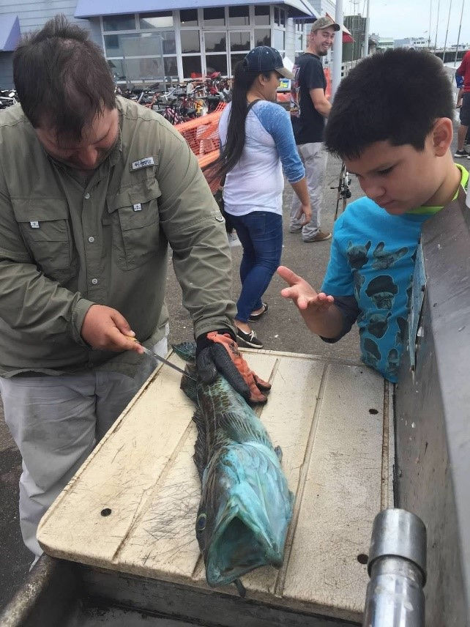

Q & A...
1. Does my cell phone work out there? Mine did even 3 miles out in the ocean (3 mi = the limit as to how far you are allowed to go in the boat) – at least mine did with Verizon.
2. What happens if the engine fails? I have never had this happen, but I carry a coiled up rope in case I need to ask another boat to tow us in. If you call the shop I believe they will send a boat to rescue you. The boat also comes with oars for emergency.
3. Is it dangerous? It’s not dangerous if you do your research, plan and prepare. Use common sense and communicate with everyone you go out with. Common boat rules such as keeping a balanced boat, limit standing, not everyone on one side that will roll the boat to that side, ect will allow you to have a great time and be safe.
4. Is there rental equipment? Yes, call the shop for pricing.
5. Can I buy supplies there? Yes, the shop has everything you can want or need except the fishing license you need to get in advance. I like to have everything I need in case there is something they might be out of, but they will typically have everything AND you get a discount as a club member!
6. Will Google Maps work in "airplane mode"? It did for me. I believe it won’t let you label a mark though if it’s on.
7. What is my biggest concern? Rough weather and seaweed or kelp. Keep the boat away from kelp which is easy to identify. If the waves start picking up, just start heading back before it gets tough to deal with waves. Plan your trips based on weather forecasts anyways and you’ll be good.
8. Will DFG (Department of Fish and Game) be there? Maybe, but sometimes not. They will inspect your catch, so make sure you follow rules as you should always do.
I hope this step by step suggested procedure helps you take your 1st step out onto a skiff. It is life changing and something worth doing in life even if just once. You don’t have to fish, just rent the skiff for an hour and go motor around the pier (clear of fishing lines, swimmers, ect) and have a picnic in the boat. It’s AWESOME!
Out on the water in the deep blue sea we have seen amazing things we would have never seen if we weren’t out there. Pods of hundreds of dolphins, a horizon with millions of birds diving to catch bait fish, countless whales, sunfish, thousands of jelly fish of many kinds, sharks, seals playing like kids, the ocean boiling with bait, cool stunt planes putting on a show for us, amazing fish we have caught as well as other creatures from the bottom, sunrises, amazing views of shore line such as natural bridges, sail boats, and more.
Tags:
- ocean
- rockfish
- Dept of Fish & Game
- Santa Cruz
- Lingcod
- Skiff
- sibiki
- Capitola
- Bonine
- Dramamine
- seasick

